**BACHELOR OF SCIENCE IN NURSING COMPLETION**

**PROGRAM CONCURRENT ENROLLMENT**

**GERMANNA COMMUNITY COLLEGE**

**AND**

**UNIVERSITY OF MARY WASHINGTON**

The University of Mary Washington (UMW) and Germanna Community College (GCC), recognizing the need for registered nurses (RNs) to achieve baccalaureate degrees in nursing through an education system that promotes seamless academic progression, hereby resolve to adopt a **Bachelor of Science in Nursing (BSN) Concurrent Enrollment Plan (B**SN-CE). This agreement is designed for GCC nursing students who are interested in completing UMW's BSN Completion Program by concurrent enrollment and does not apply to any other degree program at UMW.

The University of Mary Washington is highly supportive of the goal of enrolling GCC nursing students in the BSN Completion Program and provides several means for gaining admission in addition to this agreement. Germanna Community College nursing students who do not meet all of the terms of this agreement may nonetheless be considered competitive applicants and are encouraged to apply through the regular transfer admissions process.

The BSN Completion Program is designed for RNs who have earned an associate degree or diploma in nursing and want to complete their Bachelor of Science in nursing degree.

*This agreement permits GCC nursing students to be concurrently enrolled in the BSN Completion Program while completing an* As*sociate of Applied Science (A*.A.*S.) degree in nursing.*

**Description of the BSN Concurrent Enrollment Agreement (BSN-CE)** When students are accepted into the GCC Nursing Program, they, upon student request, will be granted admission into the BSN Completion Program at UMW as Pre-BSN students. Germanna Community College nursing students may elect to enroll in the liberal arts component of the UMW BSN Completion Program. Students will not be eligible for financial aid through UMW. Students will pay UMW tuition according to the rates established for the semesters/terms for which the student is enrolled.

**Academic Admission Agreement**

1. The University of Mary Washington agrees that students who are concurrently enrolled in GCC and UMW will earn an A.A.S. degree in nursing from GCC and a BSN in nursing from UMW if all degree requirements are met. All courses for

transfer must be completed with a grade of "C" or higher.

* + The UMW BSN Completion Program has no specific prerequisite courses for admission, beyond the A.A.S. degree in nursing and RN licensure. However, three courses within the completion program have specific course prerequisites (*see attached). Students may begin the UMW BSN Completion Program prior to the completion of these specific course prerequisites.

1. Students may begin taking UMW courses that begin with the NURS prefix after presenting a current and valid unencumbered RN license to practice nursing in the Commonwealth of Virginia.
2. Students will receive 41 credits upon presenting a current and valid unencumbered RN license to practice nursing in the Commonwealth of Virginia.
3. Students must meet all published procedures and deadlines for application to UMW and submit an application for the BSN Completion Program.
4. Students will meet the requirements of the UMW Catalog in effect at the time of their enrollment in the University or a subsequent catalog published between enrollment and graduation, as long as it is no more than five years old.
5. Degree requirement: a minimum of 30 semester hours for a baccalaureate degree must be taken at UMW. To graduate with a baccalaureate degree in nursing, a student must have a total of 120 semester credit hours.
6. The curriculum requirements in this agreement will be modified if UMW requirements are revised. Any revision will be communicated by January 1 preceding the academic year in which the new requirements take effect.

**Eligibility**

Germanna Community College students who have been accepted into the GCC A.A.S. Nursing Program are eligible for this agreement. The University of Mary Washington reserves the right to deny admission to the BSN Completion Program to students who have been suspended or dismissed from any institution of higher education or convicted of a felony, use of illegal substances, or on charges related to physical abuse towards others.

**Benefits to Germanna Community College Students**

1. The University of Mary Washington waives its application fee.
2. Through this GCC agreement, students can obtain the name and contact information for the UMW point of contact, the BSN Completion Program Director, who can advise them. Germanna Community College students accepted through this agreement will have a dedicated BSN Completion Program degree advisor upon admission.

**Responsibilities**

Germanna Community College nursing students will follow all UMW application processes, deadlines, and grade point average requirements. Germanna Community College nursing students must notify UMW of their intent to concurrently enroll in the BSN-CE (BSN Completion Plan) by completing a BSN-CE Letter of Intent, which can be accessed in the UMW Concurrent Enrollment Webpage. Germanna Community College will make available information about UMW and this agreement to BSN-CE students accepted into the A.A.S. degree in Nursing Program. The University of Mary Washington will advise students who have completed the BSN-CE (BSN Concurrent Enrollment Plan) Letter of intent regarding earning a BSN.

**Review of the Agreement**

Germanna Community College will designate officials who will be responsible for all aspects of this agreement at GCC. The University of Mary Washington will designate individuals responsible for all aspects of this agreement at UMW. The Vice President for Academic Affairs and Student Services, or a designee, will represent GCC. The Provost, or a designee, will represent UMW.

The University of Mary Washington and GCC will review and evaluate this agreement as needed.

Changes will not adversely affect students already enrolled under the provisions of the existing agreement.

This BSN-CE (BSN Concurrent Enrollment Plan) will remain in effect until terminated by either party upon written notice; such notice should be given one year in advance of the date of termination. Students who entered under the agreement may take advantage of its terms for two years after the termination becomes effective.

**History**

This agreement originated in 2014 and was signed by the GCC and UMW Presidents on August 8, 2014 and went into effect in Fall 2014. The agreement was first revised in August 2019 and was reaffirmed by the GCC and UMW Presidents in 2020.

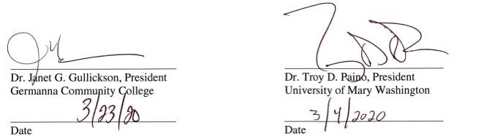

**ACADEMIC PARTNERSHIP BACHELOR OF SCIENCE IN NURSING**

**CONCURRENT ENROLLMENT PLAN**

**AND DIRECT TRANSFER ARTICULATION AGREEMENT**

**GERMANNA COMMUNITY COLLEGE A.A.S. in Nursing**

**AND UNIVERSITY OF MARY WASHINGTON BSN COMPLETION PROGRAM**

**Total Credits for BSN Degree**

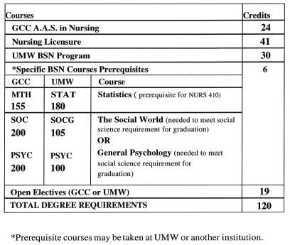

NOTE: in 2017, Germanna revised the curriculum for their AAS in Nursing; including pre-requisites. There were no changes made to the BSN-C curriculum offered at UMW

**CONCURRENT ENROLLMENT**

**AND DIRECT TRANSFER ARTICULATION AGREEMENT**

**GERMANNA COMMUNITY COLLEGE A.A.S. IN NURSING**

**AND UNIVERSITY OF MARY WASHINGTON**

**BSN COMPLETION PROGRAM**

